

DEVOPS FOR CLOUD COMPUTING
Assignment

Name:
Tehreem Mirza

Registration No:
FA22-BSE-088

Section:
BSE-8B

Submitted To:
Sir Muhammad Ibrahim

Developing three tier app with docker :
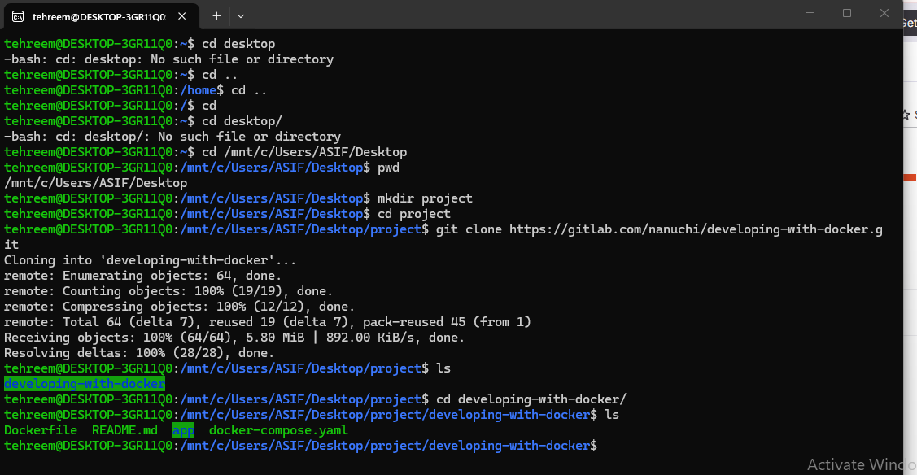

Creating mongo db network:
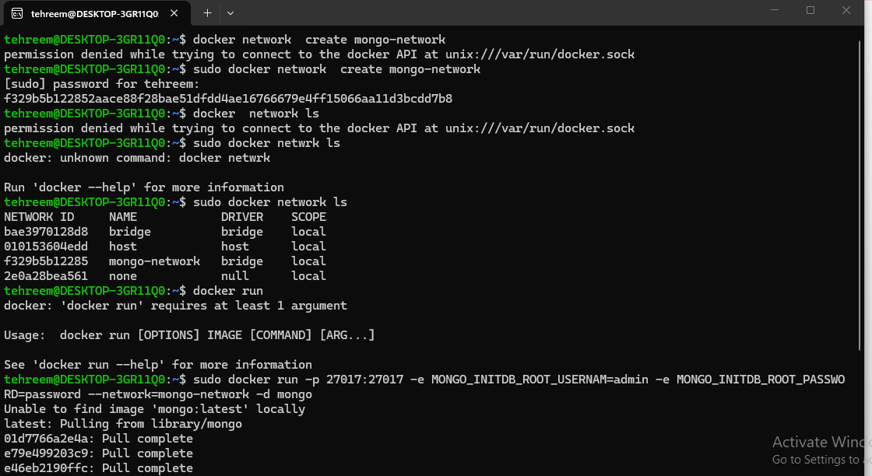

Now container is run:
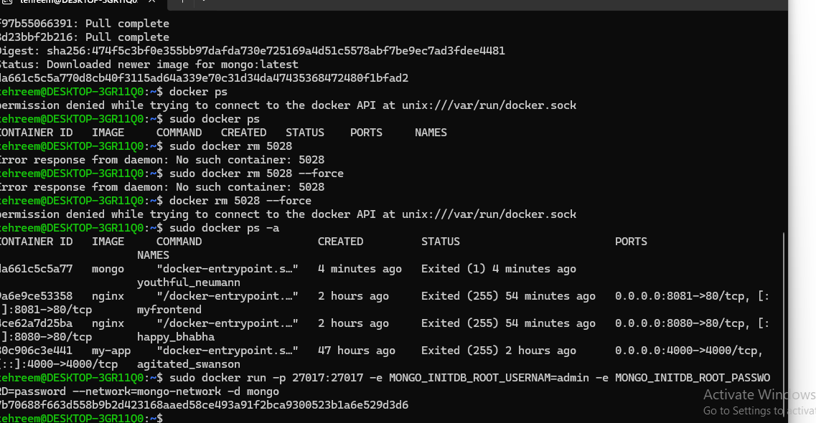

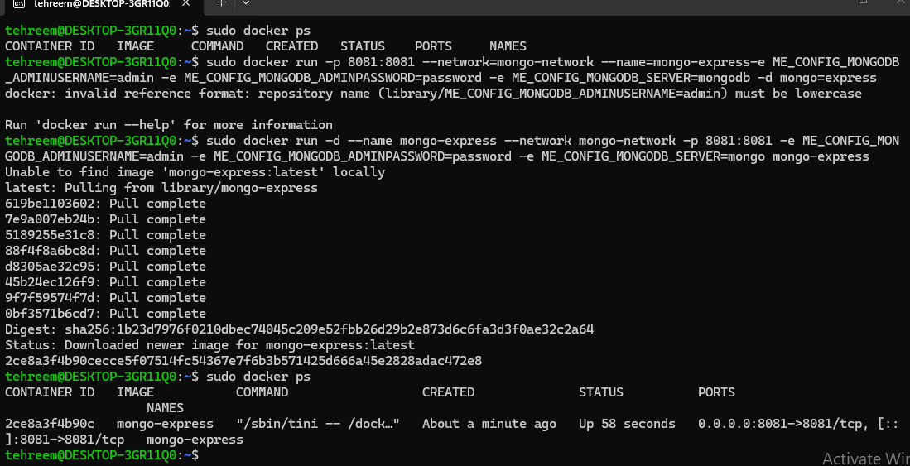

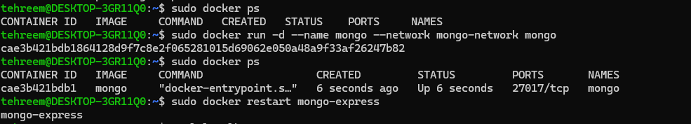

After running port:
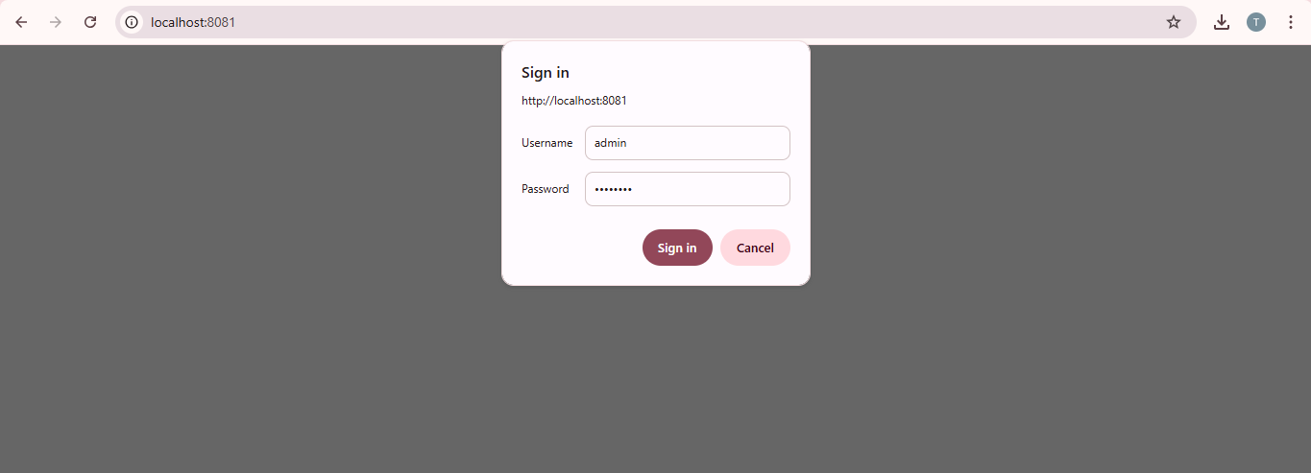

After singing in:
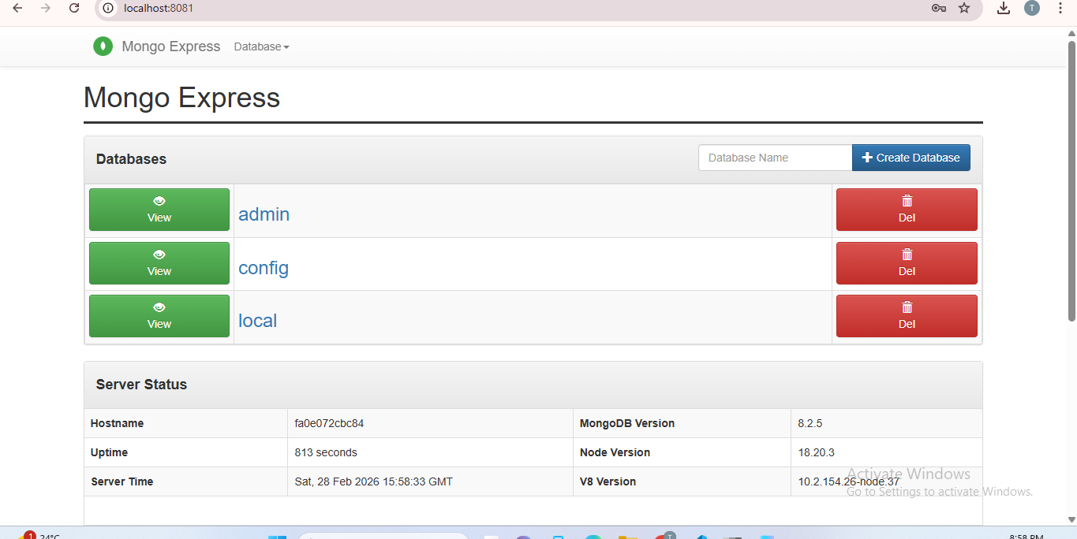

Created two databases my-db and user-accounts:
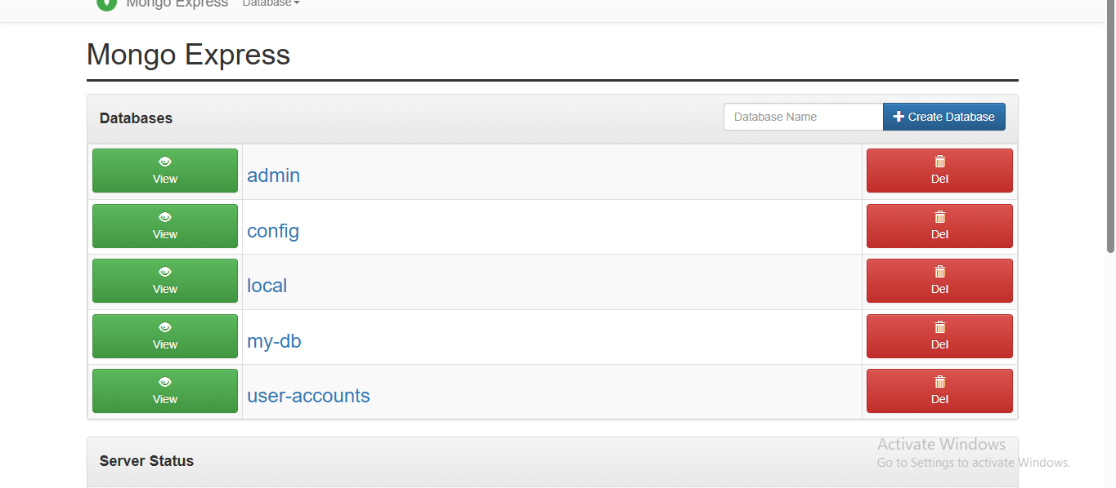

After clicking on user – accounts:
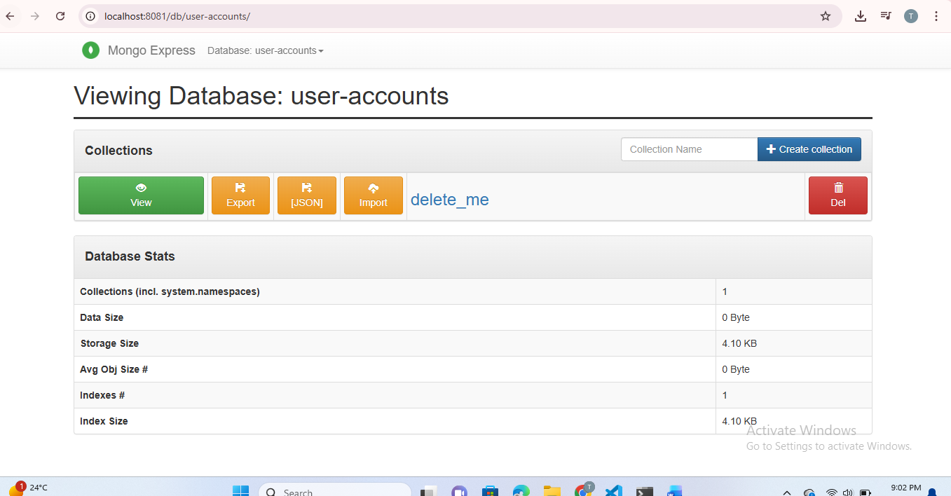

Now creating collection named user:
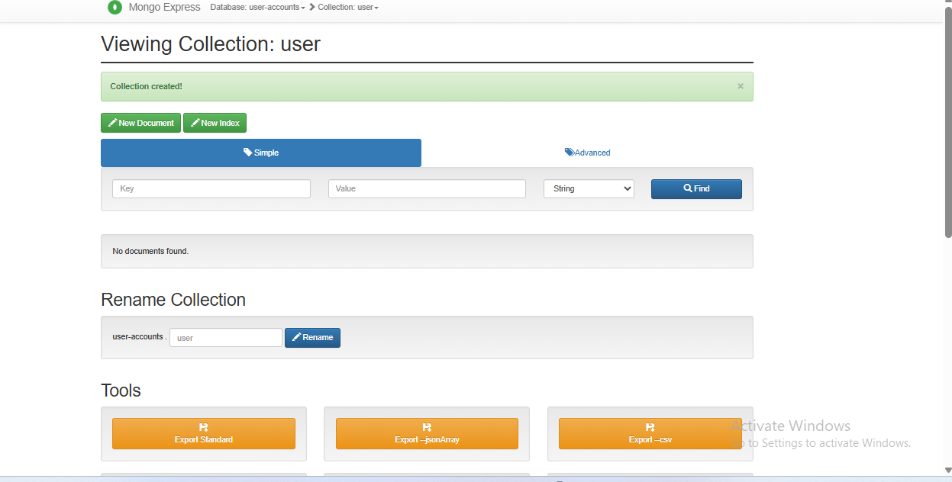

Now opening vs code for further work:
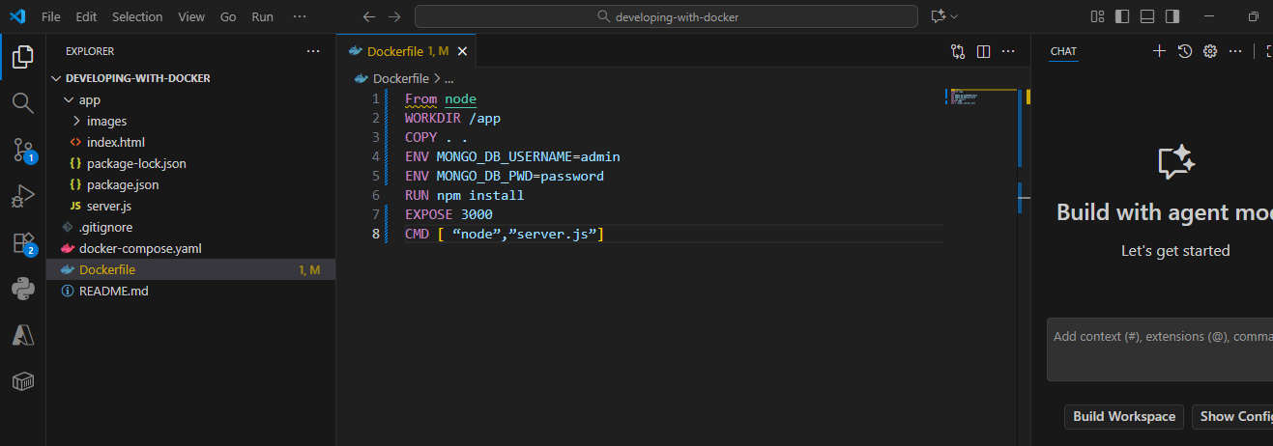

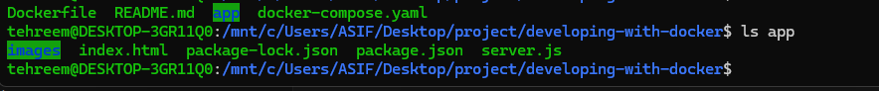

After running docker build -t nodeapp :
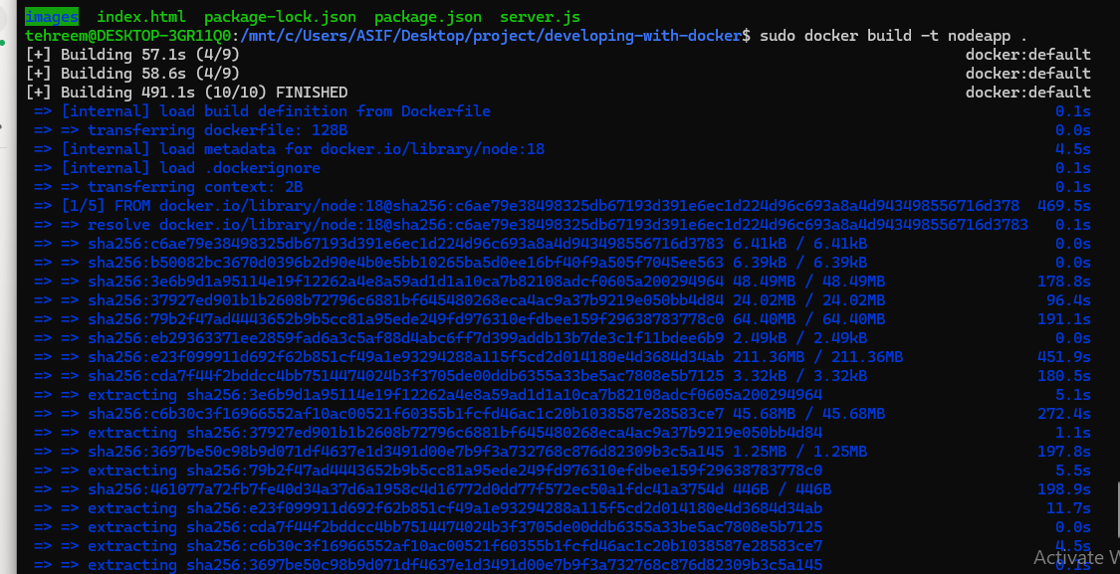
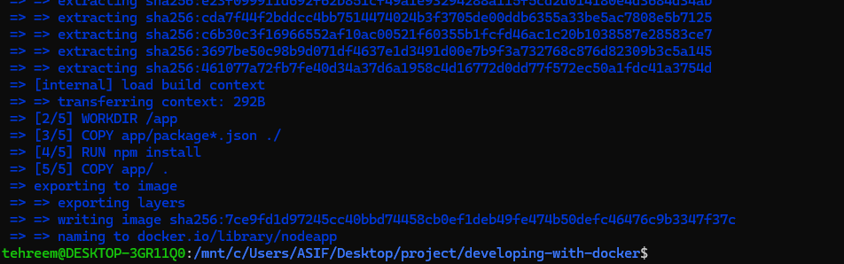
Running this docker run -d -p 3000:3000 --net mongo-network mynodeapp to start the docker container

Open your browser and go to http://localhost:3000 to check the running application. Then edit the profile information and verify the updated data in the MongoDB database to confirm that the data was successfully updated.


